**[Azure function app using CLI](https://learn.microsoft.com/en-us/azure/azure-functions/create-first-function-cli-python?tabs=windows%2Cbash%2Cazure-cli&pivots=python-mode-decorators)**

**Create a resource group named AzureFunctionsQuickstart-rg in your chosen region.**

**syed [ ~ ]$ az group create --name AzureFunctionsQuickstart-rg --location eastus**

**{**

**"id": "/subscriptions/ca54f557-4304-4731-9129-30bef740d20f/resourceGroups/AzureFunctionsQuickstart-rg",**

**"location": "eastus",**

**"managedBy": null,**

**"name": "AzureFunctionsQuickstart-rg",**

**"properties": {**

**"provisioningState": "Succeeded"**

**},**

**"tags": null,**

**"type": "Microsoft.Resources/resourceGroups"**

**}**

**Create a general-purpose storage account in your resource group and region.**

**syed [ ~ ]$ az storage account create --name myypythonfunc --location eastus --resource-group AzureFunctionsQuickstart-rg --sku Standard_LRS**

**Create the function app in Azure.**

**syed [ ~ ]$ az functionapp create --resource-group AzureFunctionsQuickstart-rg --consumption-plan-location eastus --runtime python --runtime-version 3.9 --functions-version 4 --name funcofpy --os-type linux --storage-account myypythonfunc**

**Create a local function (I am creating python one)**

**syed [ ~ ]$ func init LocalFunctionProj --python -m V2**

**Found Python version 3.9.14 (python3).**

**The new Python programming model is in public preview. Learn more at https://aka.ms/pythonprogrammingmodel**

**Writing requirements.txt**

**Writing function_app.py**

**Writing .gitignore**

**Writing host.json**

**Writing local.settings.json**

**Writing /home/syed/LocalFunctionProj/.vscode/extensions.json**

**cd LocalFunctionProj**

**Nano function_app.py**

**import azure.functions as func**

**app = func.FunctionApp()**

**@app.function_name(name="HttpExample")**

**@app.route(route="hello")**

**def test_function(req: func.HttpRequest) -> func.HttpResponse:**

**return func.HttpResponse("HttpExample function processed a request!")**

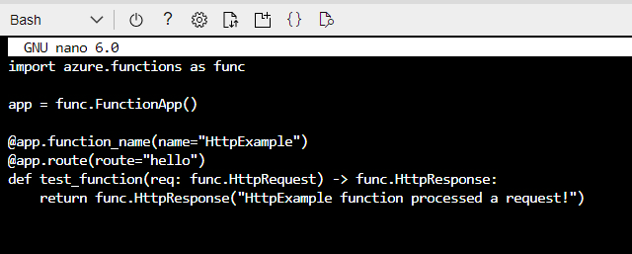

**Nano local.settings.json**

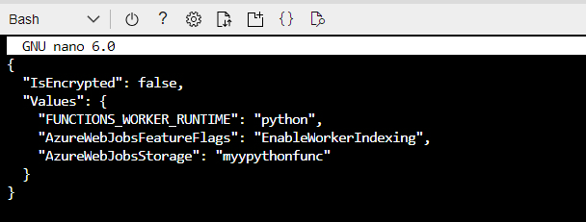

Make sure to give your azure storage inplace of AzureWebJobsStorage

To publish the app use:

func azure functionapp publish funcofpy

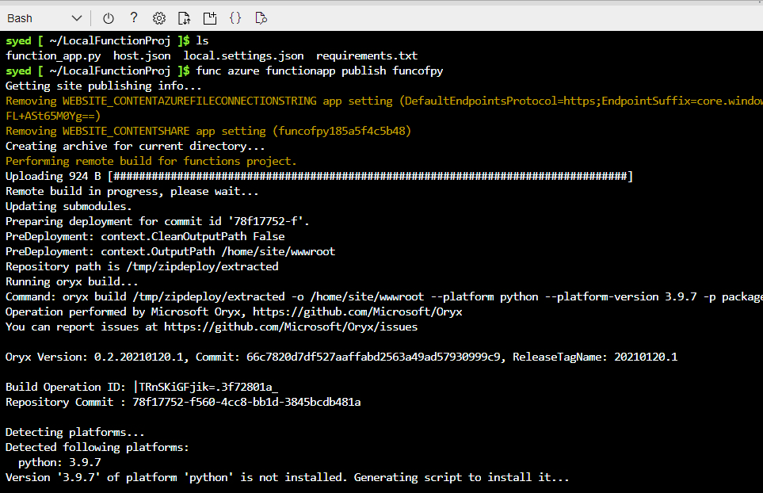

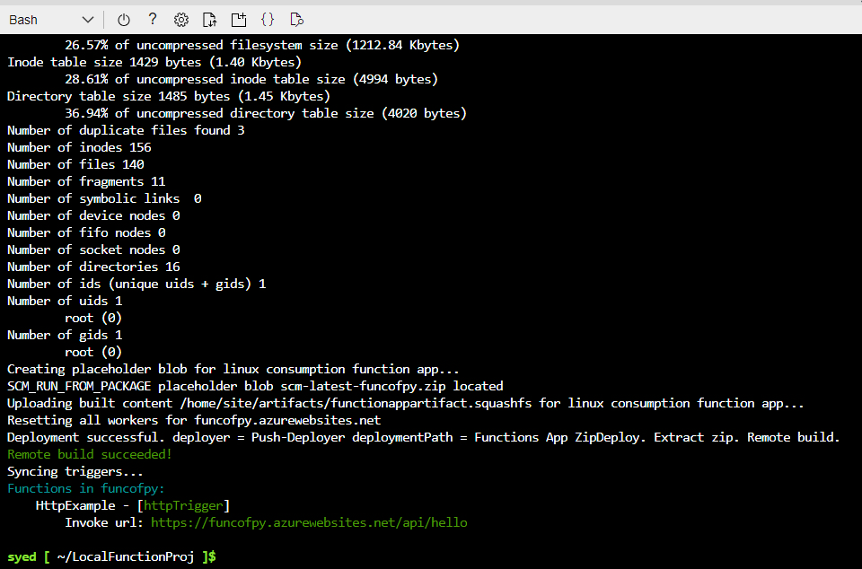

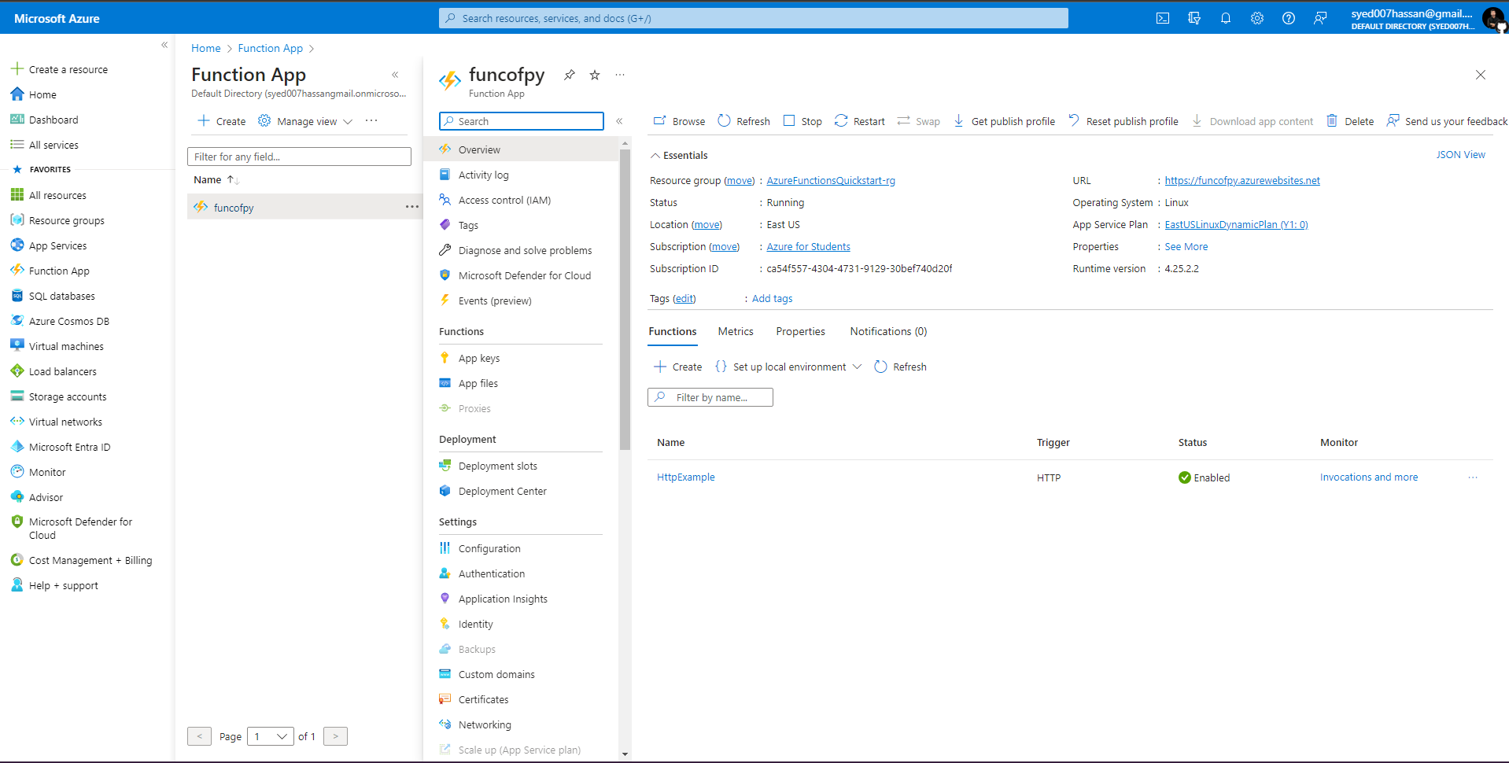

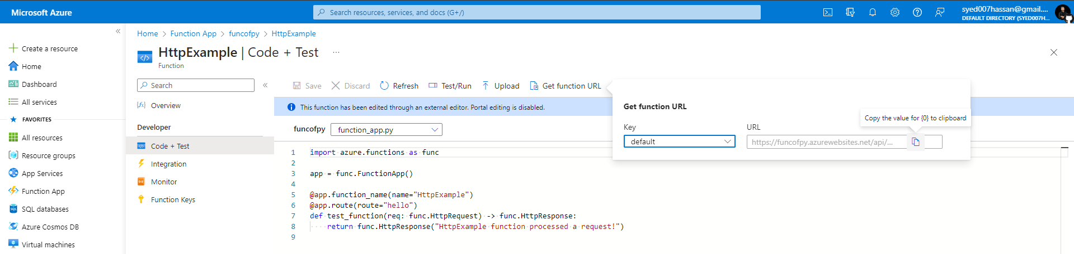



Successful API response with 200 status code :)